Shopee

Business Architecture Document

Version 0.1

Revision History

|  |  |  |  |
| --- | --- | --- | --- |
| **Date** | **Version** | **Description** | **Author** |
| 6, November, 2023 | 0.1 | Final | Nguyen Huyen Anh  Nguyen Thi Hien Anh |
|  |  |  |  |
|  |  |  |  |
|  |  |  |  |

Table of Contents

1. Introduction 4

○ Purpose 4

○ Scope 4

○ Definitions, Acronyms, and Abbreviations 4

○ References 4

○ Overview 4

2. Architectural Representation 4

3. Architectural Goals and Constraints 4

Architectural Goals 4

Architectural Constraints 4

4. Business Process View 5

5. Organization Structure View 5

○ Business Use-Case Realizations 6

6. Cultural View 6

7. Human Resource Aspects View 6

8. Domain View (optional) 6

9. Size and Performance Goals 6

10. Quality Goals 6

Business Architecture Document

# Introduction

## Purpose

This document provides a comprehensive architectural overview of the system, using several different architectural views to depict different aspects of the system. It is intended to capture and convey the significant architectural decisions which have been made on the system.

## Scope

This Business Architecture Document provides an architectural overview of Shopee – an e-commerce system developed by Sea Ltd. It will provide the general view of the Shopee platform, which contains both software and hardware to operate this system.

## Definitions, Acronyms, and Abbreviations

e-commerce: electronic commerce

## References

## Overview

# Architectural Representation

**Software Architecture View**

Admin: Administrator of Shopee, manages modules

Users: people who are

* Guests: Browse and search for the products and their information
* Customer (Registered account): Inherit from guest, other functions such as add product to cart or favorite section, communicate to system and sellers(other users), check out, place order, give feedback on products
* Seller: Functions to sell: upload products, communicate with users, view and respond to feedback,...

# Architectural Goals and Constraints

## Architectural Goals

* Scalability: The Shopee system must be able to handle a large number of concurrent users and transactions, both now and in the future.
* Reliability: The Shopee system must be highly reliable and available, with minimal downtime.
* Performance: The Shopee system must be responsive and performant, with users able to complete tasks quickly and easily.
* Security: The Shopee system must be secure, protecting user data and financial transactions.
* Maintainability: The Shopee system must be well-designed and easy to maintain, so that new features can be added and bugs can be fixed quickly and efficiently.

## Architectural Constraints

* Cost: The Shopee system must be developed and operated within a reasonable budget.
* Technology: The Shopee system must be built using technologies that are available, affordable, and scalable.
* Time to market: The Shopee system must be developed and launched within a reasonable timeframe.
* Compliance: The Shopee system must comply with all applicable laws and regulations.

# Business Process View

This part will show an overview of the business process of online shopping platform - Shopee by using Use Case diagram.

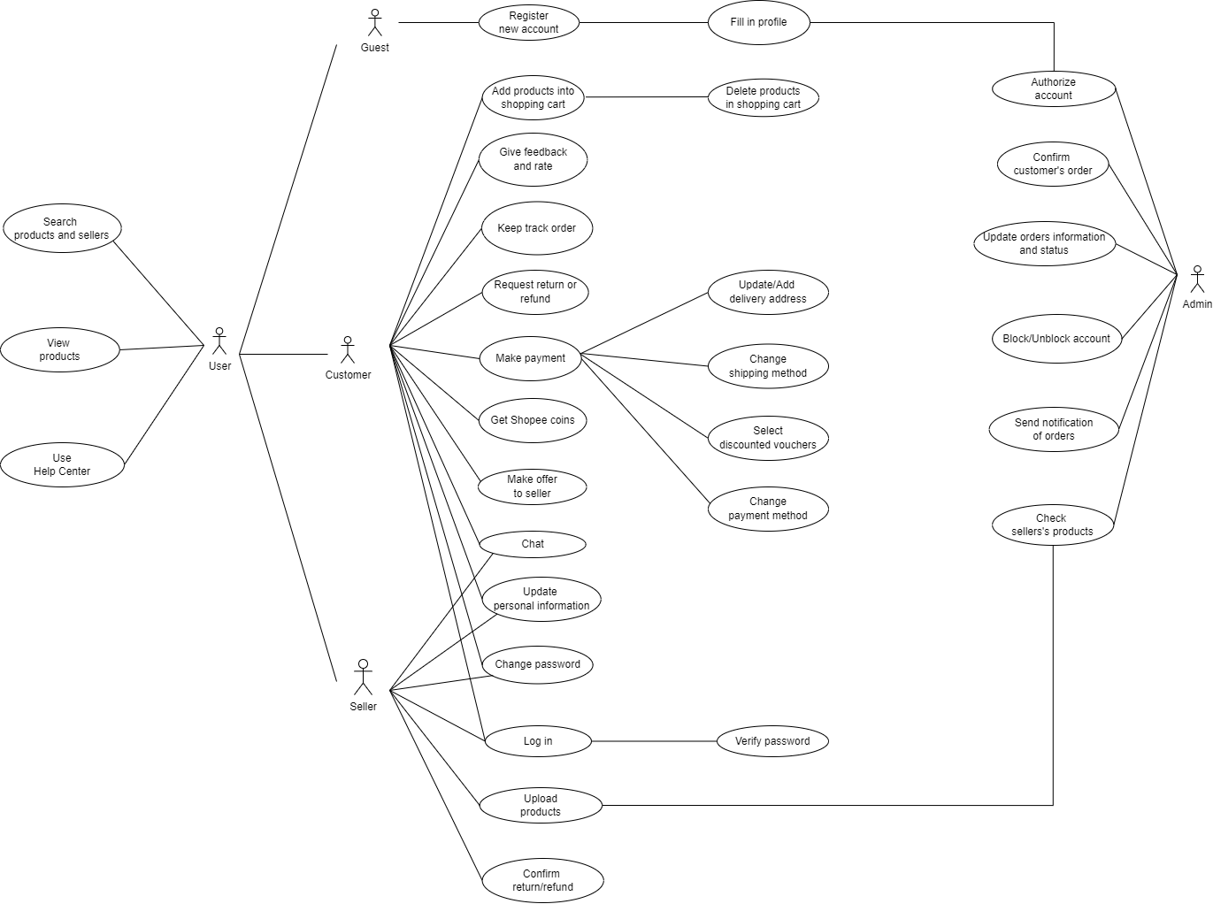

# Organization Structure View

The company is divided into several key business units, including:

* Product: Responsible for developing and improving the Shopee platform, including the mobile app, website, and seller tools.
* Operations: Responsible for the day-to-day execution of the business, including logistics, customer service, and payments.
* Marketing: Responsible for promoting the Shopee platform and acquiring new users and sellers.
* Business Development: Responsible for developing new partnerships and expanding Shopee's reach into new markets.

Each business unit is led by a senior executive who reports directly to the CEO. The company also has a number of cross-functional teams, such as engineering, data science, and design, that support all of the business units.

## Business Use-Case Realizations

NA.

# Cultural View

Shopee's culture is characterized by its focus on innovation, collaboration, and customer-centricity. The company believes that these values are essential for success in the rapidly changing e-commerce landscape.

Innovation is a top priority at Shopee. The company encourages employees to come up with new ideas and to experiment with new ways of doing things. Shopee also invests heavily in research and development, and the company is constantly looking for new ways to improve the user experience and the Shopee platform.

Collaboration is another key value at Shopee. The company believes that teamwork is essential for success, and employees are encouraged to work together to achieve common goals. Shopee also has a number of programs and initiatives to support collaboration, such as cross-functional teams and regular team meetings.

Customer-centricity is at the heart of Shopee's culture. Shopee focuses on understanding and meeting the needs of customers, ensuring a positive user experience, and building long-term relationships. The company believes that the customer is always right, and employees are encouraged to go the extra mile to provide a great customer experience. Shopee also invests heavily in customer service, and the company is committed to resolving customer issues quickly and efficiently.

# Human Resource Aspects View

Shopee's human resource (HR) practices are designed to support the company's mission to make e-commerce accessible to everyone in Southeast Asia. The company's HR team focuses on attracting, developing, and retaining top talent, while also creating a positive and productive work environment for all employees.

# Domain View (optional)

Shopee is an e-commerce platform that allows users to buy and sell goods and services online. The company's business domain includes all of the activities and processes involved in running the platform, such as product management, marketing, sales, customer service, and logistics.

# Size and Performance Goals

The size of Shopee's database is estimated to be in the hundreds of terabytes. Shopee had deployed more than 20 TiDB clusters in the production environment with over 400 nodes. The data size was more than 200 TB at the time. For registered capital, it must be higher than 100 000 RMB. Additionally, the system's live business product URL must utilize a TLS 1.2 Protocol and begin with “https://”. Shopee’s performance targets for sellers are grouped into four categories: listing violations, fulfillment, customer service, and customer satisfaction.

# Quality Goals

Product quality: Shopee aims to ensure that all products sold on its platform are of high quality. It does this by requiring sellers to meet certain standards, such as providing accurate product descriptions and images, and by having a team of quality assurance experts review products before they are listed for sale.

Delivery speed and accuracy: Shopee aims to deliver products to buyers quickly and accurately. It does this by working with a network of reliable logistics partners, and by tracking orders throughout the delivery process.

User experience: Shopee aims to provide its users with a user-friendly interface and a variety of payment options. It does this by regularly updating its app and website, and by offering a variety of payment methods, including cash on delivery and credit card payments.

Security: Shopee aims to protect customer data and privacy. It does this by using industry-standard security measures to protect its servers and databases, and by requiring sellers to comply with its privacy policy.